Part 1: Design Document

- Describe a business problem that can be solved with a database solution and is in alignment with the chosen scenario.

EcoMart is an online marketplace that connects sustainability-minded consumers with brands and products that align with their values. EcoMart’s data is dynamic, diverse, and unstructured, and requires regular updates and changes. As EcoMart’s catalog and user base grow, product data changes frequently and varies widely, with some items including product updates, extensive ingredient lists, and seasonal availability. EcoMart’s core business problem is that it cannot reliably integrate its rapidly changing, semi-structured products. Currently, the company uses a relational database solution; however, trying to make this a fix rows and columns solution leads to slow onboarding of products and results in delays and inconsistencies in information for shoppers and missed opportunities to highlight promotions to customers. A MongoDB database solution is needed to unify flexible product detail and fast-growing transactions in one place, so teams can load new items quickly, maintain consistent search/filter experiences, and generate timely insights to support recommendations, promotions, and inventory decisions, aligning with the business goal of supporting a scalable, sustainable marketplace

- Justify why a NoSQL database solution will solve the identified business problem.

A MongoDB document-oriented NoSQL database would be a perfect solution, as the company will be able to store each product as a flexible document, so items can have different fields without redesigning tables (MongoDB, n.d.). According to LinkedIn (2022), MongoDB, a document database solution, lets the company ingest product data as a flexible JSON-like document. Documents are a very flexible and powerful way to store data and have many advantages over tables (LinkedIn, 2022). In addition, because details for a product live inside one document, many reads require no joins, which keeps common lookups fast and straightforward (MongoDB, n.d.). As the company grows, replication keeps the site available and sharding spreads data across servers so performance scales with traffic (MongoDB, n.d.). In short, MongoDB onboards products faster, adapts to changing attributes, and analyzes activity at scale, which supports EcoMart’s data needs.

- Identify a NoSQL database type to solve the identified business problem.

The recommended NoSQL type for EcoMart, is a document database, specifically MongoDB. A document store keeps each product or transaction as a flexible JSON-like record so items can have different fields without redesigning tables (MongoDB, n.d.). Within MongoDB, EcoMart’s data is organized as documents stored in collections (i.e. cosmetics, groceries) inside the d597 database; this structure preserves the flexible, JSON-like records that a document store is designed to handle. This model matches EcoMart’s constant updates need, supports fast reads with fewer joins, and scales horizontally as data and traffic grow through indexing, replication, and sharding features MongoDB provides (MongoDB, n.d.).

- Explain how the business data will be used within the database solution.
EcoMart will use the database as a single, organized repository to keep all product information. Each item can be recorded with the details, and new information can simply be added to the same record as information evolves, avoiding inconsistencies (MongoDB, n.d). Because item details are kept together, staff can quickly locate products by brand, price range, or customer-valued attributes and keep filters and product pages current. Over time, these item changes can be reviewed to identify patterns for the most updated attributes, or which categories see more activity, supporting better planning and communication.

B. Discuss how the proposed database design addresses scalability concerns, including strategies that align with the chosen scenario.

The design relies on horizontal scaling and simple performance practices. Targeted indexes are applied on high-traffic filters such as Brand, Name, itemDescription, and meta.updatedAt to accelerate “find by name,” “recently updated,” and “most frequently updated” views; (2) predictable bulk operations (e.g., price updates or new attribute backfills) are batched during low-traffic windows; and (3) optional sharding by a stable key (such as category or brand) can be introduced when collection size or traffic warrants horizontal scale. Together with replication for availability and rolling upgrades, these choices keep read latency low as the catalog grows while preserving fast, safe writes for frequent updates.

C. Outline the privacy and security measures that should be implemented in the proposed database design.

To secure the proposed database, custom roles should be enforced to provide granular authorization aligned to specific tasks and applications (LinkedIn, 2022). In addition, audit logging must be enabled to capture administrative actions and access to sensitive operations, supporting traceability and governance (MongoDB, n.d.). Encryption will be enforced both in transit (TLS) and at rest; access will follow least-privilege RBAC with custom roles for analysts (read-only), data stewards (curated updates), and administrators (restricted and audited). Where necessary, sensitive fields will be isolated behind restricted views or field-level policies, and regular backups plus access reviews will support recovery and governance (MongoDB, n.d.).

Part 2: Implementation
Note: The data files for both scenarios are located in the Supporting Documents section. Be sure to pull the files that relate to your chosen scenario.
Note: Submit your screenshots from the WGU Virtual Lab for each prompt with your design document.

D. Implement the proposed database design in the WGU Virtual Lab environment by completing the following:

- Write script to create a database instance named “D597 Task 2” using the appropriate query language, based on your design in Part 1. Provide a screenshot showing the script and the database instance in the platform.

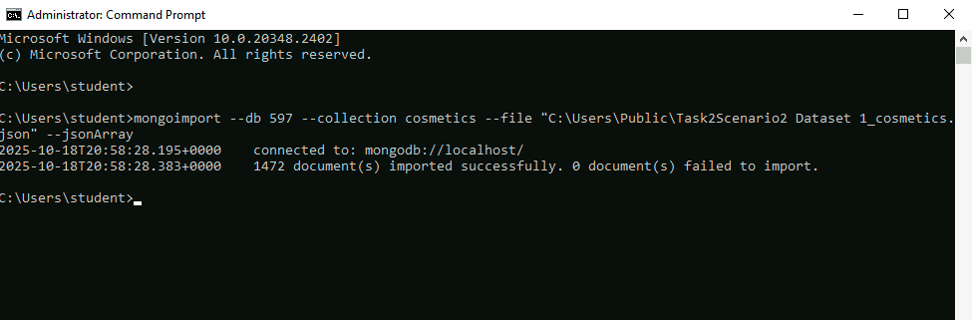

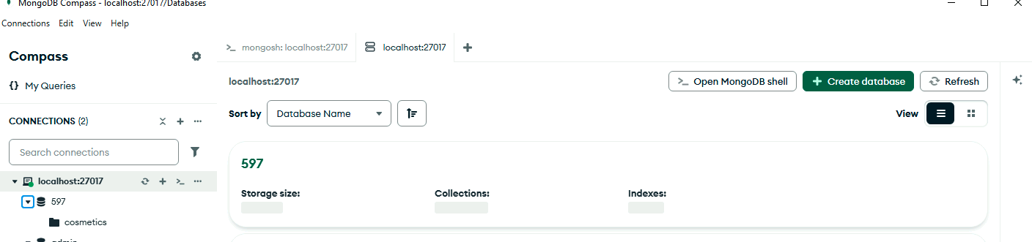
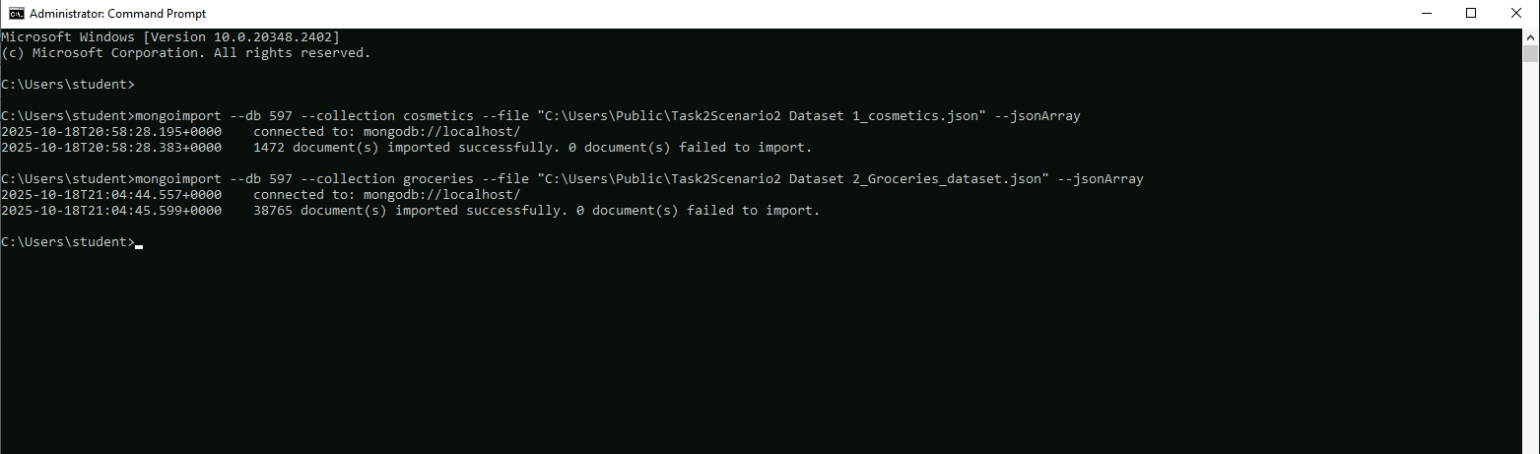
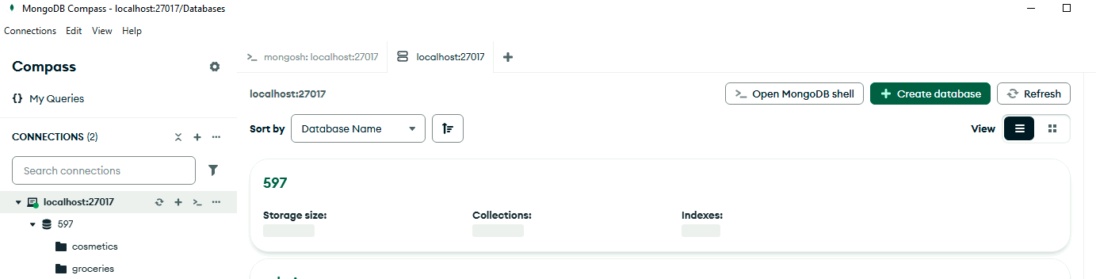

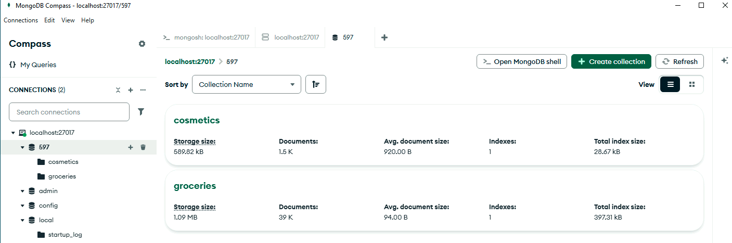

- Write script to insert or map the data records from the chosen scenario JSON files into the database instance. Provide a screenshot showing the script and the data correctly inserted or mapped into the database.



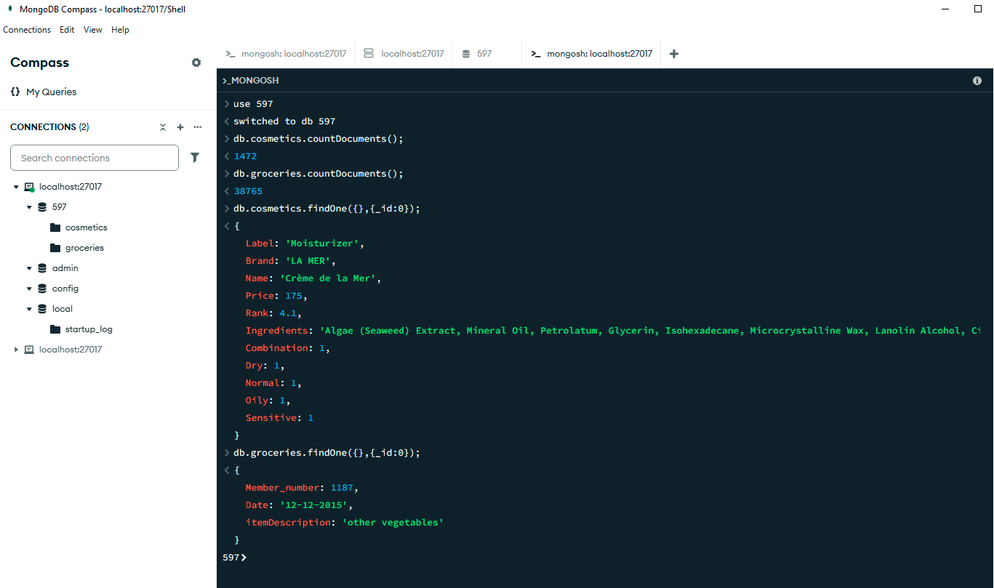

- Write script for three queries to retrieve specific information from the database that will help to solve the identified business problem. Provide a screenshot showing the script for each query and each query successfully executed.

- Business problem solved: Fast onboarding of a new/updated product without redesigning tables; every change is tracked.

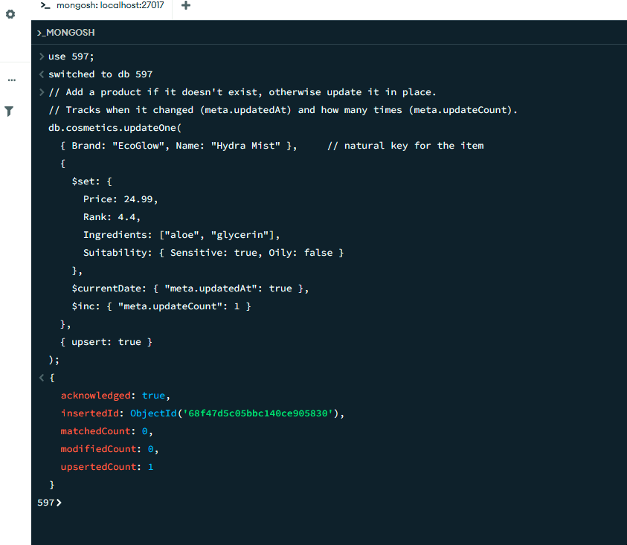

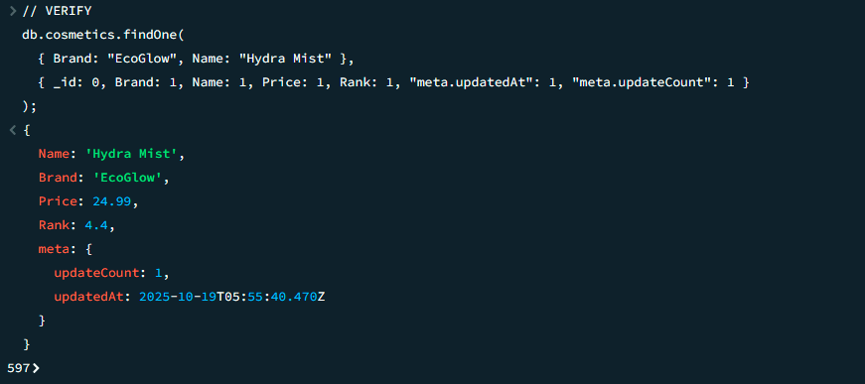

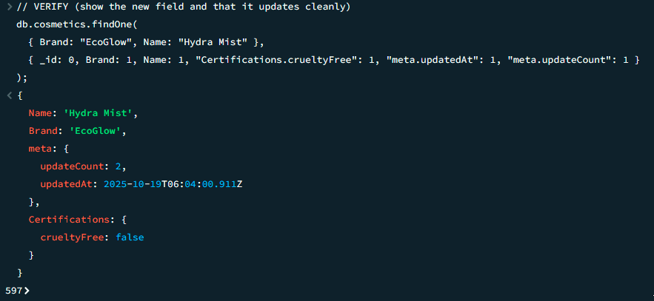

- Business problem solved: Introduce a new filter/label (e.g., “organic”) across many items at once, then refine items per item overtime.

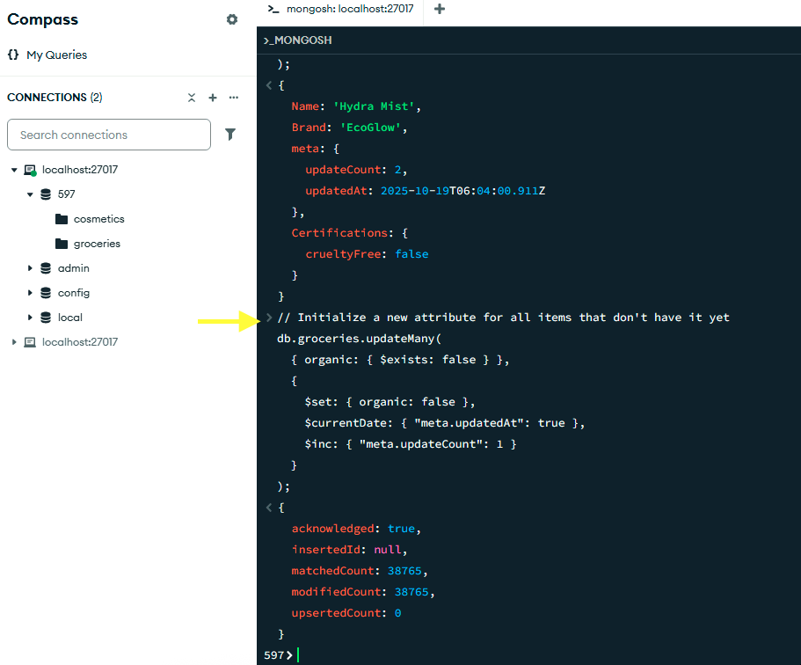

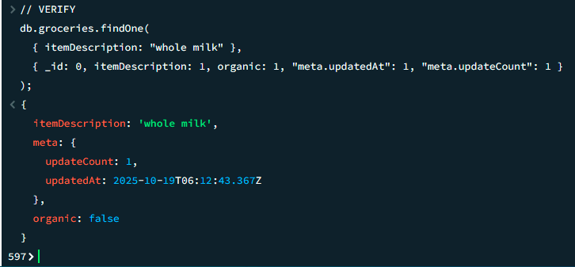

- Business problem solved: Keep the current price accurate and maintain audit-friendly history of price changes for reporting and promotions.

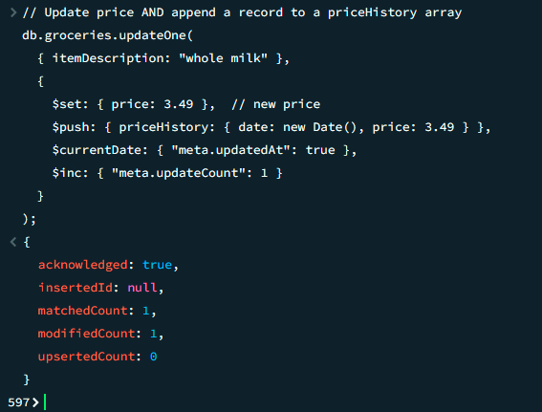

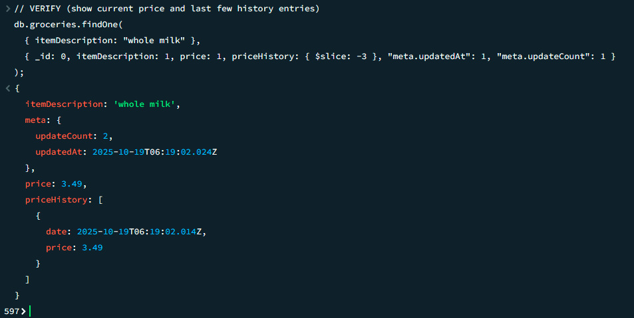

- Apply optimization techniques to improve the run time of your queries from part D3, providing output results via a screenshot.

According to Medium (2025, May 20), Indexes can significantly accelerate read performance. Each index is created on a collection. In some cases, a compound index Medium (2025, May 20) was created when indexes are needed over multiple single fields for queries consistently use the same combination of fields.

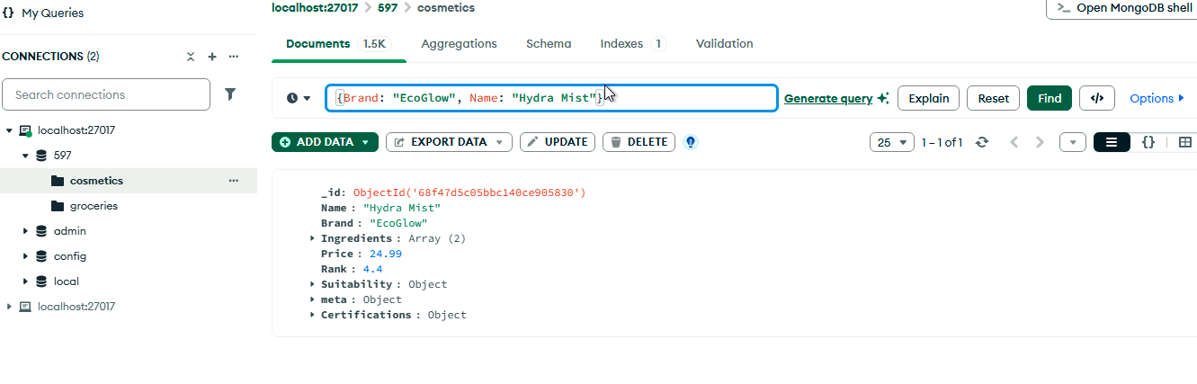
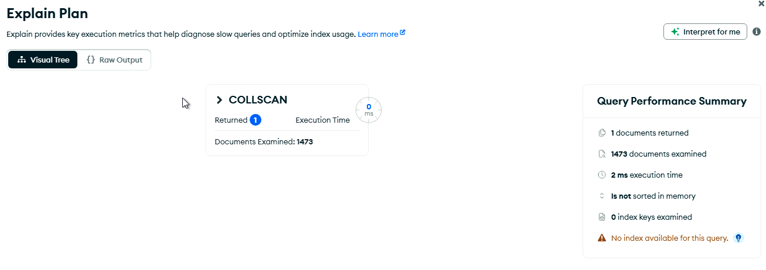

Index:


Explain Plan after Index:

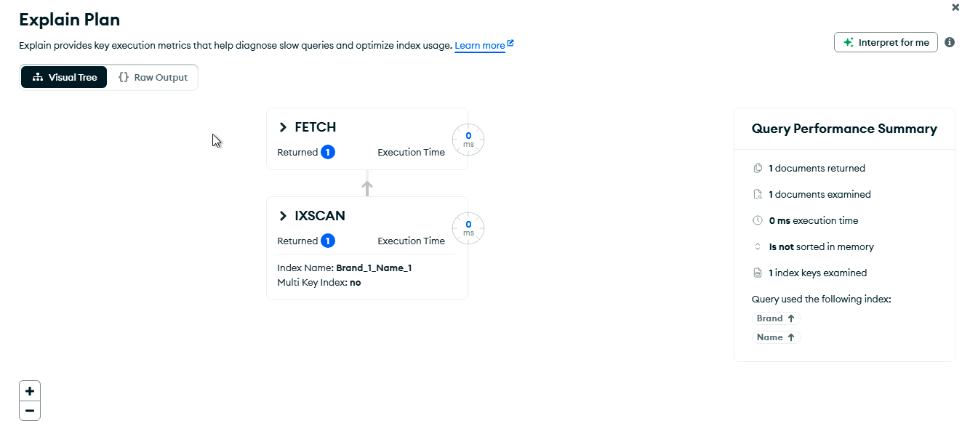

2.

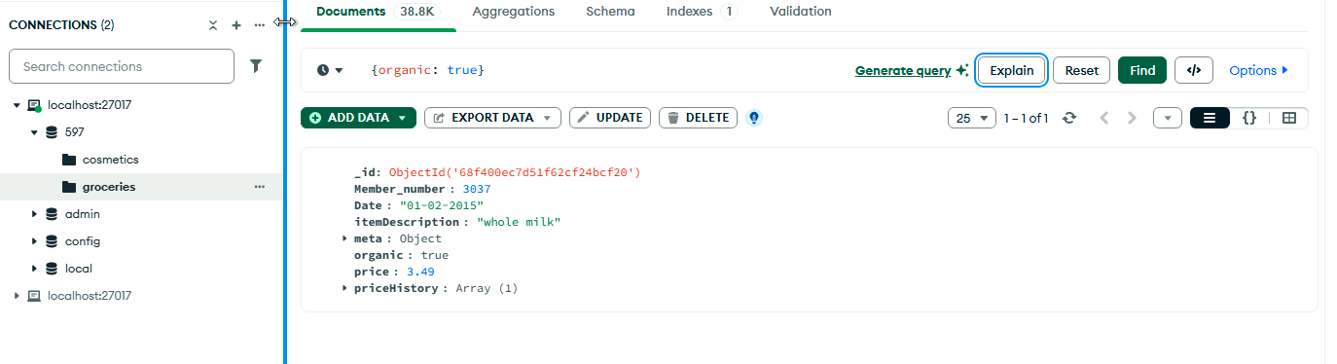
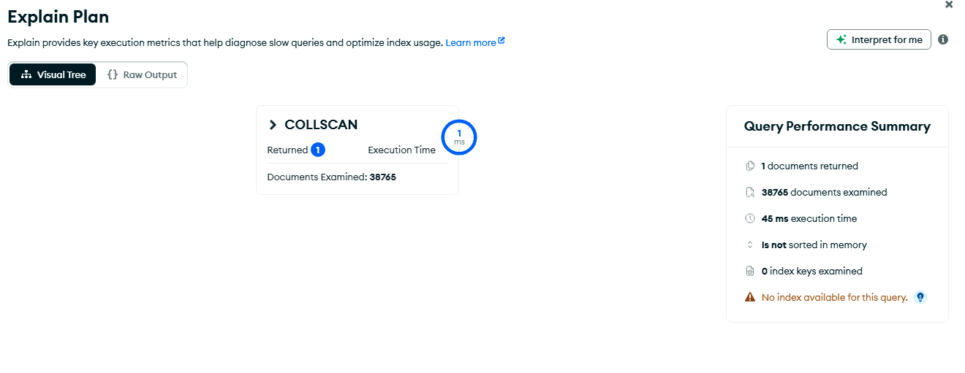
Index:
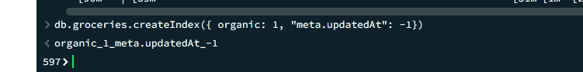

Explain Plan after Index:

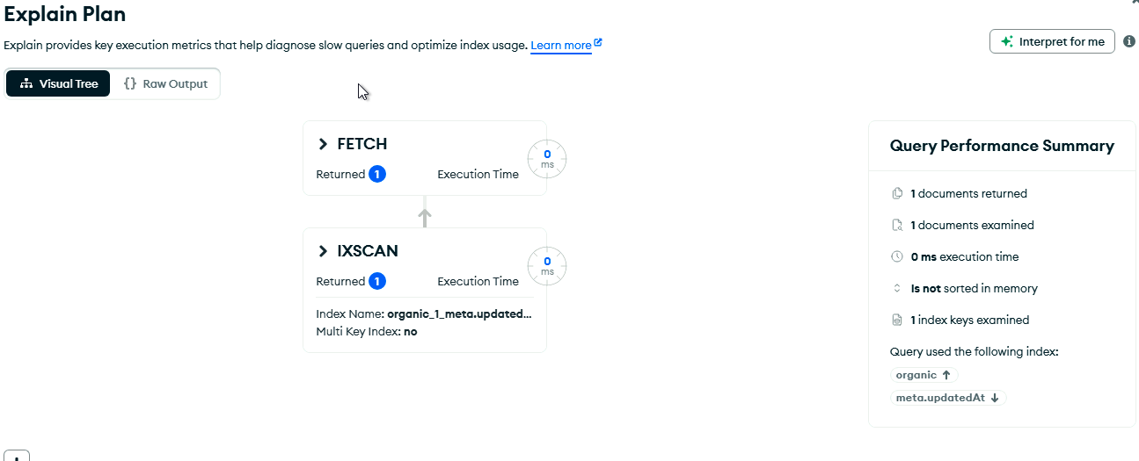

3.

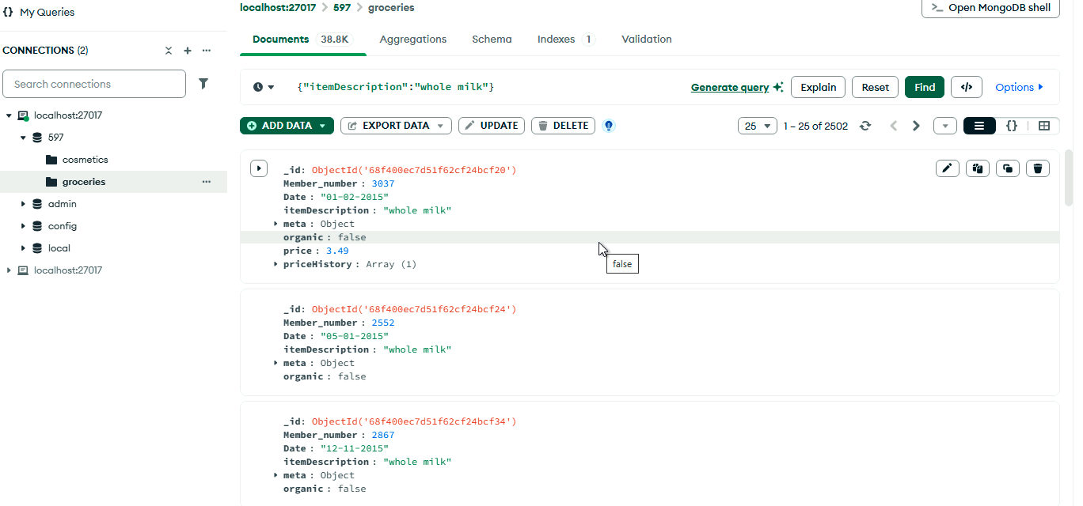
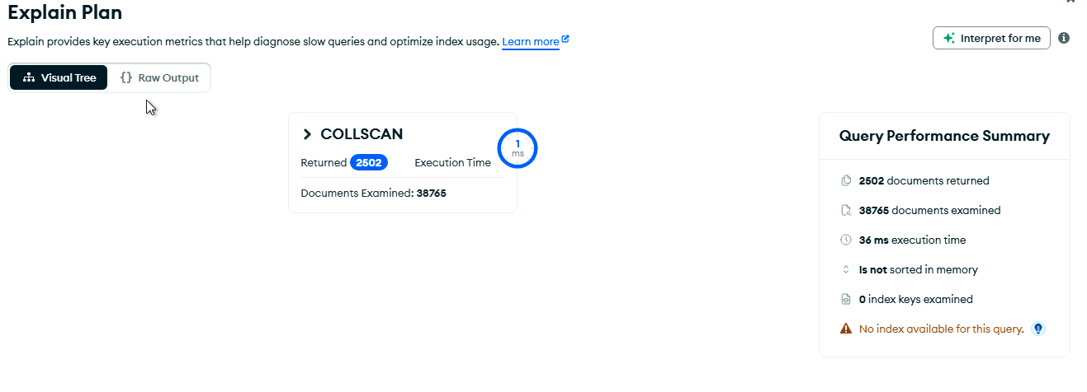
Index:

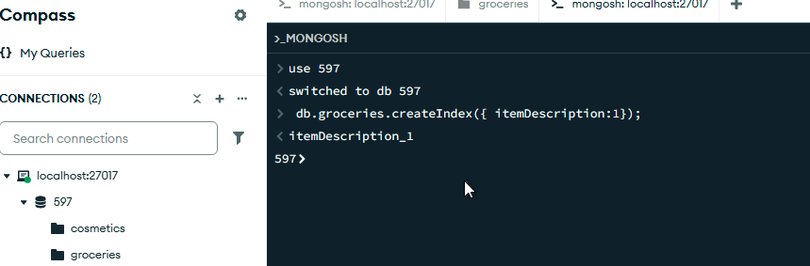

Explain Plan after Index:
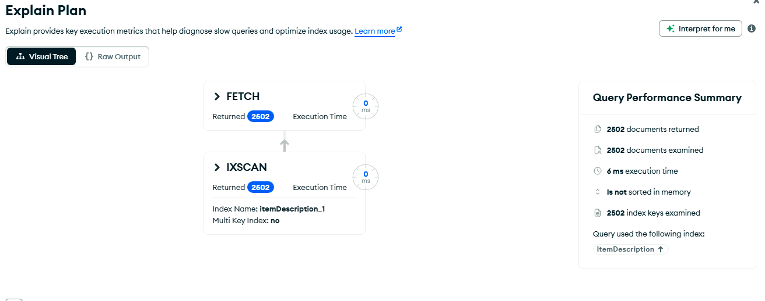

Sources
[LinkedIn]. (2022, December 16). Learning MongoDB [Video]. LinkedIn. https://www.linkedin.com/learning/learning-mongodb-17360744/mongodb-vs-relational-databases?resume=false&u=2045532

MongoDB (n.d.). What is NoSQL? MongoDB.com. https://www.mongodb.com/resources/basics/databases/nosql-explained

MongoDB. (n.d.). NoSQL database security. https://www.mongodb.com/resources/products/capabilities/nosql-database-security

MongoDB (n.d.). Database Scaling. MongoDB.com. https://www.mongodb.com/resources/basics/scaling

Medium (2025, May 20). Your Guide to Optimizing Slow Queries. Medium.com. https://medium.com/mongodb/your-guide-to-optimizing-slow-queries-f69cf413ee71

